# My Implementation

The scene consists of a terrain covered in grass, a castle featuring a (normal map), a fire with smoke and logs (normal map). A shark is in the water using a reflection shader to demonstrate the ability for the shader to compute reflections on complex shapes.

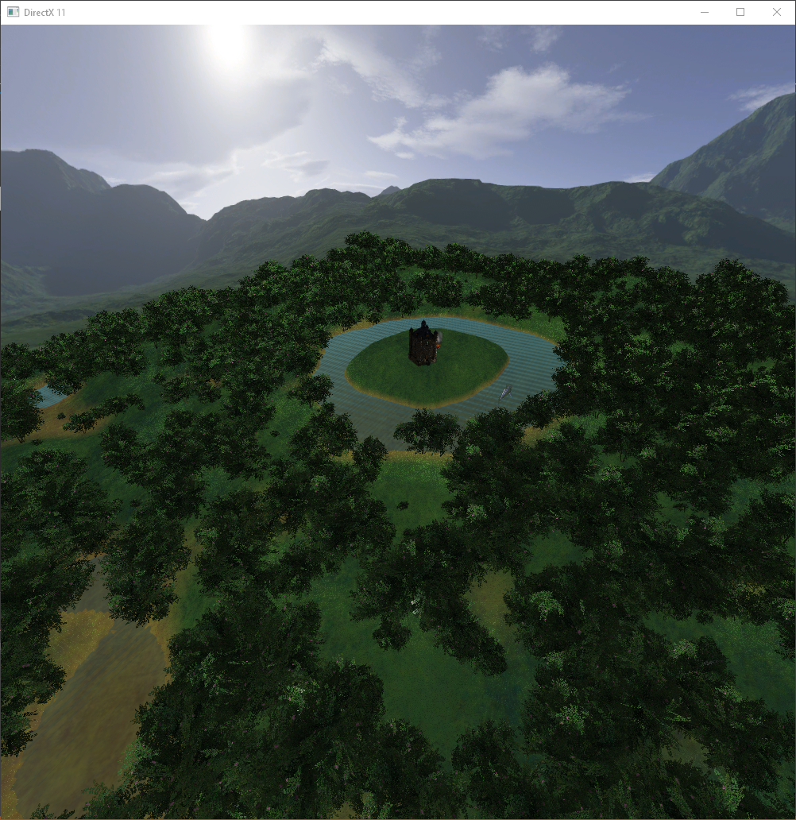

Figure : Scene view with flying First Person Camera

# Techniques

## Per Pixel Lighting

Per Pixel Lighting shaders are used within the scene to render the lighting illumination for each pixel on a model. A modified version of the shader is utilized on the castle (modified to support normal maps).

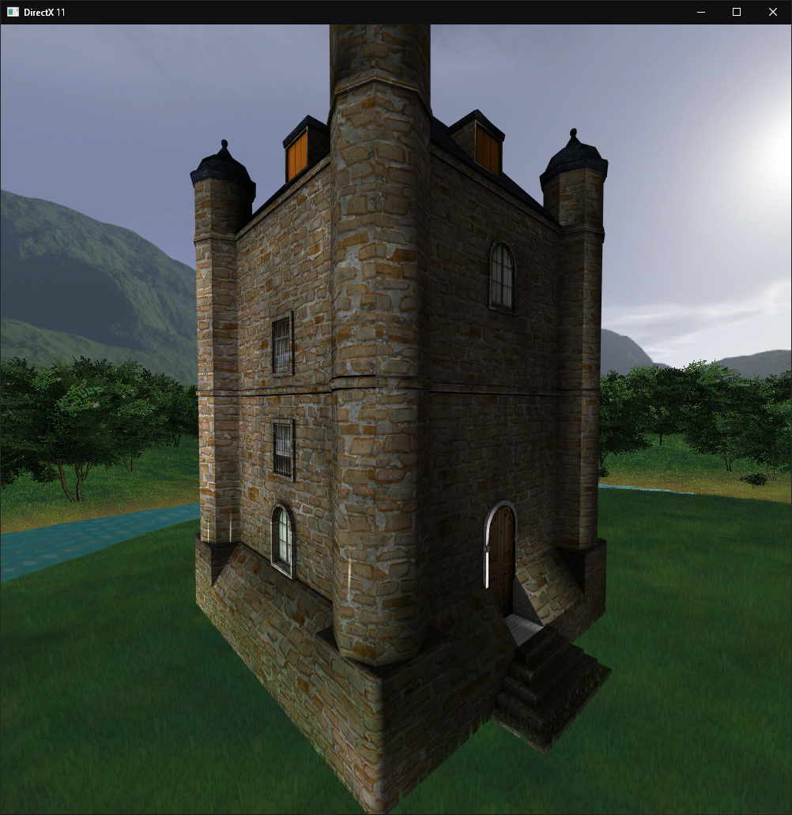

Figure : Castle using per pixel lighting.

## Particle Systems

A particle system is used to generate the fire and smoke in the scene. The particle system creates particles and propels them in a defined direction.

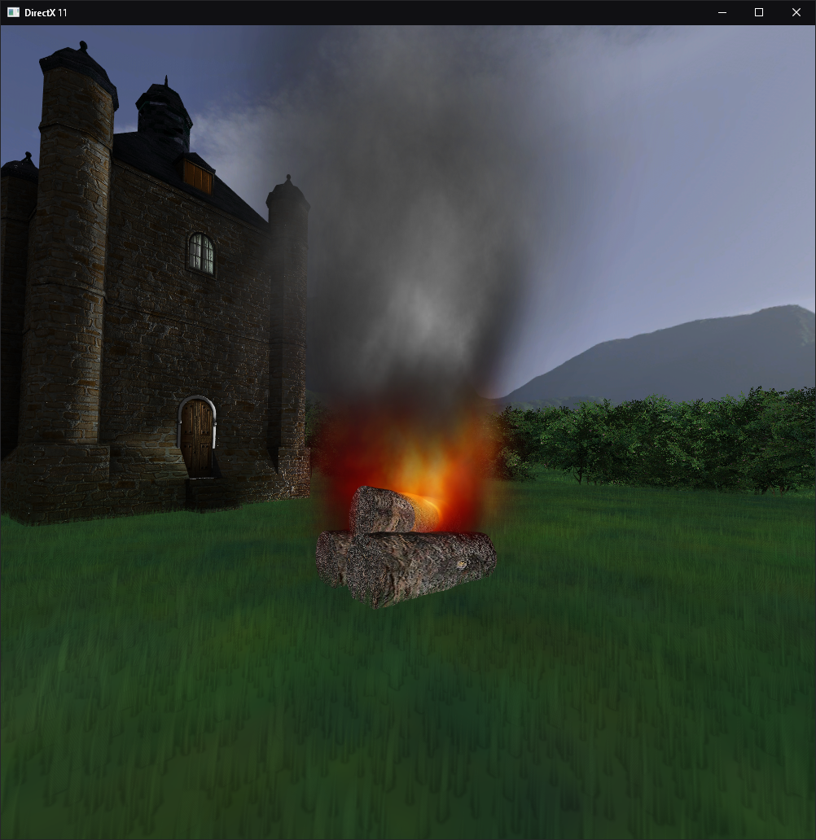

Figure : Fire using Particle System

## Tree Generation

The generation done using an array of trees. Positions would be randomly selected as long as they were not within the region of the island which contained the castle.

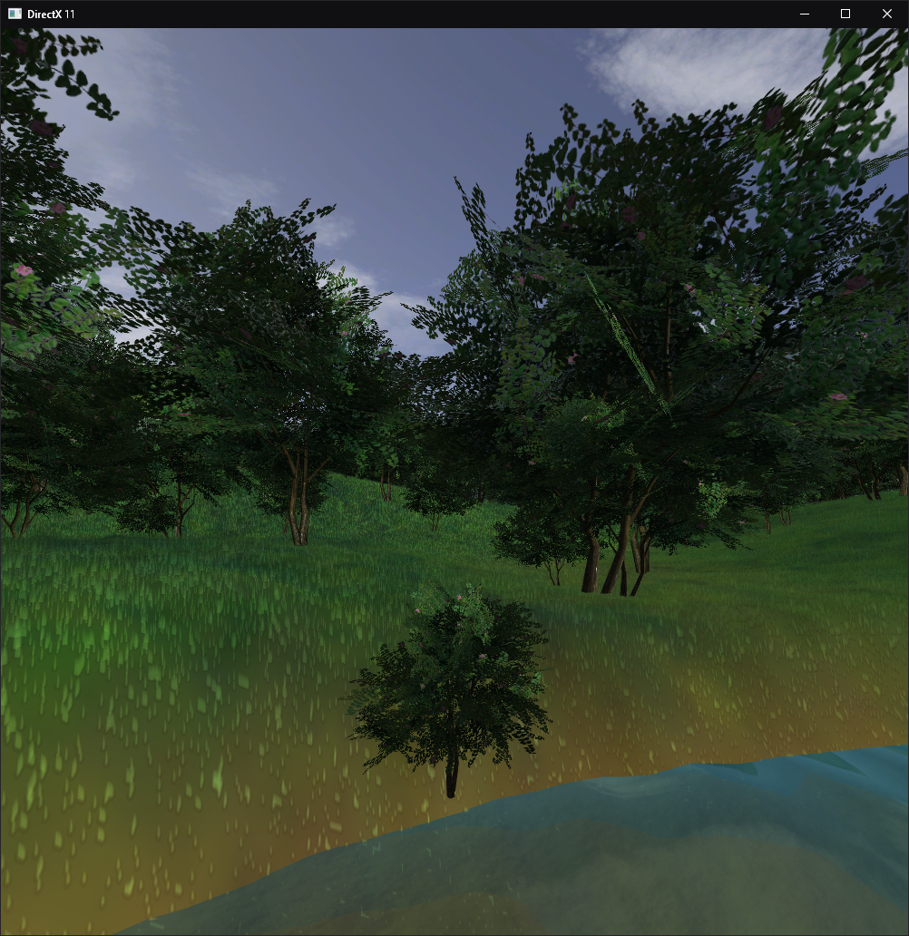

Figure : Tree generation showing random positions, sizes and rotations.

## Alpha Blending

Alpha bending allows for textures to contain transparency. This is utilized on the water to provide it with a transparent finish, along with on the trees, smoke/fire and grass.

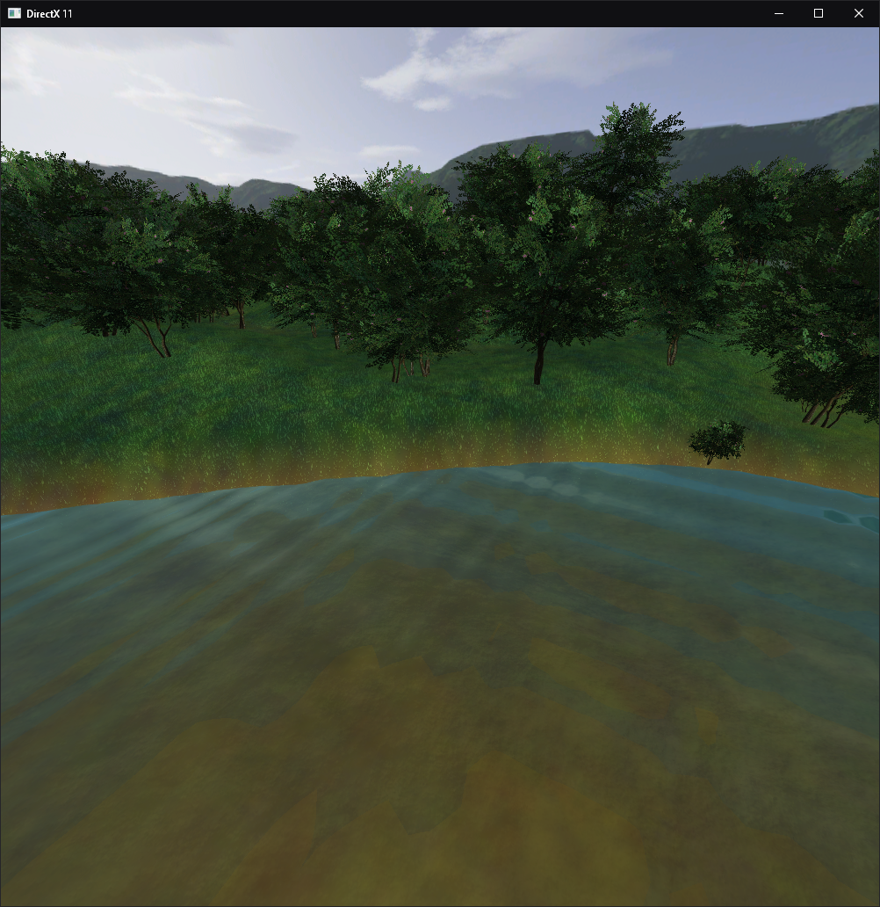

Figure : Image of water transparency and tree transparency

## Grass creation

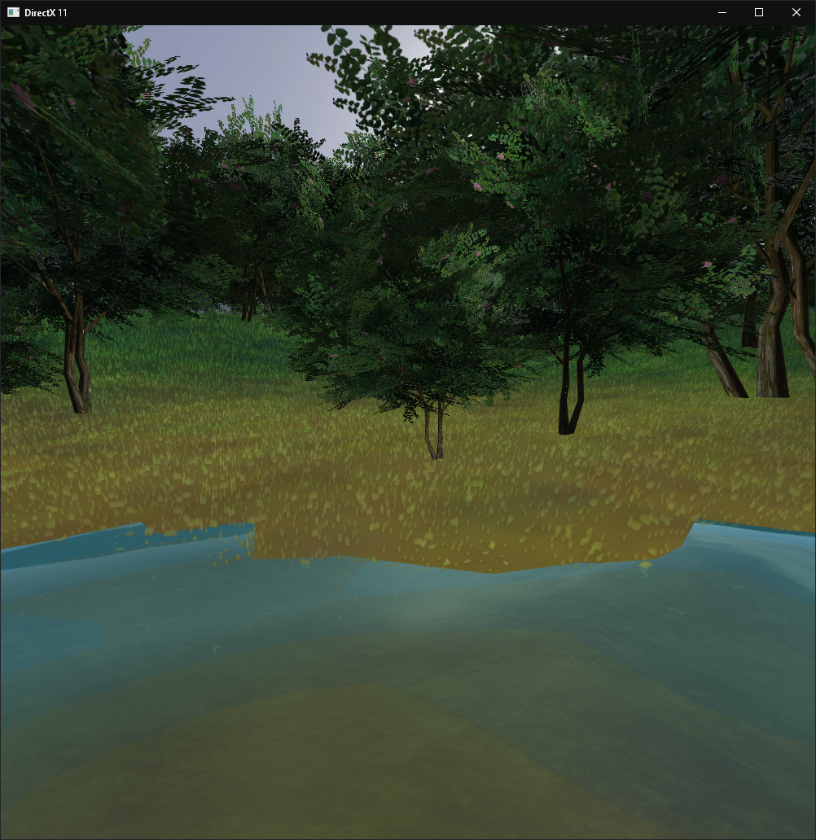

Figure : Grass creation with fade away from water.

## Normal Mapping

Normal mapping refers to utilizing a special image to add extra depth to a 2D surface. This provides it with the appearance of a higher quality model that would require more vertices, without the added complexity or processing power impact. This information is passed into the shader and through calculating the bitangent the shading can be altered to provide the aforementioned 3D effect.

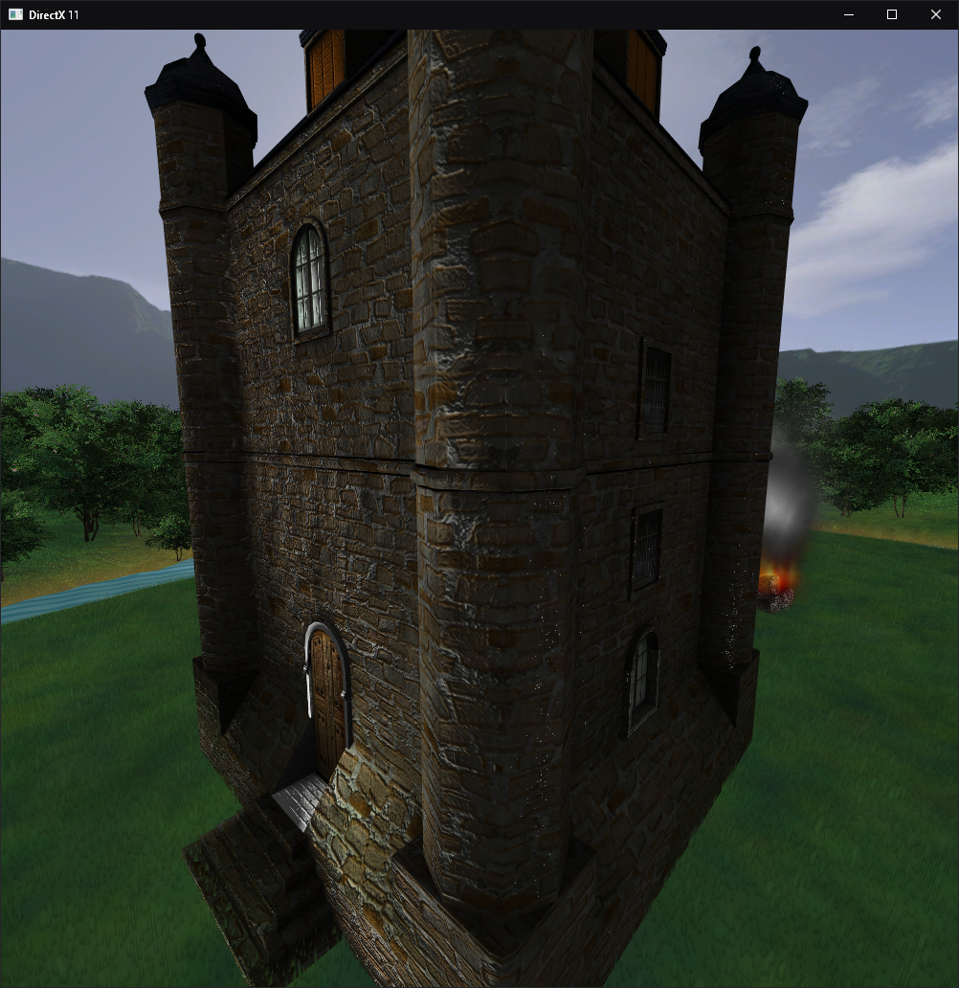

Figure : Castle with Normal Map applied

# Testing